
Project on
PREDICTIVE MAINTENANCE
& FAILURE MODE ANALYSIS of Stone Crusher Machines
Submitted by
Varsha
Under the supervision of
Prof. Dr. Millie Pant
Department of Applied Mathematics and Scientific Computing, IIT Roorkee
Duration: 09/06/2026 to 15/07/2026

Table of Contents
1. Executive Summary
2. Introduction & Problem Statement
3. Dataset Description
3A. Methodology Overview
4. Exploratory Data Analysis
5. Failure Mode Analysis
6. Data Preprocessing & Feature Engineering
7. Handling Class Imbalance
8. Machine Learning Models
9. Model Evaluation
10. Model Comparison
11. Failure Mode Classification — Multi-Class Task
12. Conclusion & Recommendations
Appendix A: Detailed Classification Reports
Appendix B: Glossary of Metrics and Terms
Appendix C: Reproducibility & Environment
Appendix D: Descriptive Statistics

1. Executive Summary
This report covers a full predictive-maintenance study built on the AI4I 2020 Predictive Maintenance Dataset, a well-known benchmark of 10,000 industrial machine records. The goal was simple to state but harder to solve: predict whether a machine is about to fail, figure out which of five possible failure mechanisms is behind it when it does fail, and check whether newer generative-AI methods can beat older statistical techniques at fixing the dataset's heavy class imbalance (only 3.39% of the records are actual failures).
The work moved through ten stages — collecting and inspecting the data, exploring it, studying the failure modes individually, preprocessing and engineering features, correcting the imbalance (both the classic way and with generative AI), training models, evaluating them, comparing them, and finally pushing the whole pipeline further into a multi-class version that names the failure type instead of just flagging "failure" or "no failure."
Seven binary classifiers were built and tested in total: three Logistic Regression variants (trained on the raw data, on SMOTE-balanced data, and on CTGAN-generated data), a K-Nearest Neighbors model, a Support Vector Machine, a Decision Tree, and a Random Forest. Random Forest with balanced class weights came out clearly on top — F1-Score of 85.7%, Precision of 95.7%, Recall of 77.6%, ROC-AUC of 0.978, and PR-AUC of 0.863. No other model came close.
Among the classic resampling methods, Borderline-SMOTE gave the best F1-Score (0.320). The CTGAN generative approach, on the other hand, actually performed worse than plain SMOTE — most likely because there were only 254 real failure examples to train the generator on, which just isn't enough for a deep model like CTGAN to learn from properly.
When the problem was extended to a six-way classification (naming which of the five failure modes — TWF, HDF, PWF, OSF, RNF — occurred, or none at all), a SMOTE-balanced Random Forest reached a Macro F1-Score of 95.34% and a Weighted F1-Score of 99.90%. In other words, once the imbalance is handled properly, the failure types are quite easy to tell apart.
Overall, the report recommends deploying the class-weighted Random Forest as the main failure detector, using Borderline-SMOTE instead of CTGAN whenever resampling is still needed (given how few failure examples exist), and moving toward the multi-class version so maintenance teams get a specific diagnosis rather than a plain yes/no alert.

2. Introduction & Problem Statement

2.1 Background
Unplanned downtime is one of the most expensive things that can happen on a production line. Fixing machines on a rigid schedule wastes parts that still had useful life left, while waiting until something actually breaks is risky and usually more costly. Predictive maintenance tries to find a middle ground: use sensor readings and machine learning to catch warning signs early, so repairs can be scheduled exactly when they're needed instead of too early or too late.
The AI4I 2020 dataset is a synthetic dataset, but it's built to closely mimic a real milling machine. It records air temperature, process temperature, rotational speed, torque, and tool wear, along with a single yes/no failure flag and five separate flags marking which specific failure mechanism triggered.

2.2 Problem Statement
- Failures are rare — only 339 out of 10,000 records (3.39%) — so a lazy classifier can just guess "no failure" every time and still look accurate on paper, while missing almost every real failure.
- Failures aren't all the same. They come from five different, mostly independent causes (tool wear, heat dissipation, power problems, overstrain, and pure random failure), each with its own physical threshold.
- Different oversampling and generative techniques make different trade-offs when creating synthetic minority-class data, and which one actually works best on a small tabular dataset like this one isn't obvious ahead of time.

2.3 Objectives
- Build a clean, well-understood dataset through careful collection, exploration, and preprocessing.
- Study and quantify the five failure modes individually.
- Compare classic resampling methods (Random Oversampling, Random Undersampling, SMOTE and its variants) against generative-AI methods (CTGAN, TVAE) for fixing the imbalance.
- Train and properly evaluate several ML classifiers using metrics suited to imbalanced data — Precision, Recall, F1, ROC-AUC, PR-AUC — rather than relying on accuracy.
- Extend the binary detector into a multi-class model that names the responsible failure mechanism.
- Turn the findings into practical deployment recommendations.

2.4 Report Structure
Section 3 introduces the dataset. Section 4 covers the exploratory analysis. Section 5 looks closely at the five failure modes. Section 6 explains preprocessing and feature engineering. Section 7 compares the different imbalance-handling techniques. Section 8 describes the models built. Section 9 evaluates them. Section 10 compares all models side by side. Section 11 extends the work into multi-class classification, and Section 12 wraps up with conclusions and recommendations.

3. Dataset Description

3.1 Source and Scale
The dataset comes from the UCI Machine Learning Repository (AI4I 2020 Predictive Maintenance Dataset). It has 10,000 rows and 14 columns, and there are no missing values anywhere in it.

3.2 Column Overview
Column | Type | Description
UID | Integer | Just a record ID; dropped before modeling
Product ID | String | Product identifier; first letter shows quality (L/M/H)
Type | Categorical | Product quality variant: L (Low), M (Medium), H (High)
Air temperature [K] | Numeric | Ambient air temperature in Kelvin
Process temperature [K] | Numeric | Process temperature in Kelvin
Rotational speed [rpm] | Numeric | Tool rotational speed
Torque [Nm] | Numeric | Torque applied
Tool wear [min] | Numeric | Total tool wear in minutes
Machine failure | Binary | Target: 1 if any failure mode triggered, else 0
TWF / HDF / PWF / OSF / RNF | Binary (×5) | Flags for each specific failure mode

3.3 Class Balance
The Machine failure column is badly imbalanced — 9,661 non-failure records against just 339 failures (3.39%). This imbalance is really the central problem the whole project revolves around.
Class | Count | Percentage
Non-Failure (0) | 9,661 | 96.61%
Failure (1) | 339 | 3.39%

3.4 Product Quality Distribution
The Type column, which marks product quality, roughly breaks down as: L (Low quality) about 50% of records, M (Medium quality) about 30%, and H (High quality) about 20%.

3A. Methodology Overview
The overall workflow followed a fairly standard pipeline for imbalanced tabular data: collect the data, explore it, study the failure modes, preprocess and engineer features, fix the imbalance (classic and generative), train models, evaluate them carefully with imbalance-aware metrics, and finally push into multi-class diagnosis. Each stage feeds into the next, and the same held-out test set — never touched by any resampling or generation step — was used for every final evaluation in Sections 9 to 11, so the comparison across techniques stays fair.

3A.1 Tools and Environment
Everything was done in a Jupyter Notebook using Python 3. pandas and NumPy handled the data, matplotlib and seaborn did the visualizations, scikit-learn covered preprocessing, modeling, and evaluation, imbalanced-learn (imblearn) handled the classic resampling methods, and the SDV library (CTGAN, TVAE, CopulaGAN) handled generative synthesis. t-SNE (from scikit-learn) and UMAP were used to visualize real vs. synthetic data in reduced dimensions.

3A.2 Evaluation Philosophy
Since the failure class is only 3.39% of the data, basically every decision in this project — which resampling method to use, which metric to trust — was made with that imbalance in mind. Accuracy is reported for completeness, but it isn't trusted as the main measure of success; Precision, Recall, F1-Score, ROC-AUC, and especially PR-AUC (which holds up much better under heavy imbalance) are the metrics actually relied on.

4. Exploratory Data Analysis

4.1 Class Distribution
As shown in Section 3.3, only 3.39% of records are failures. This was checked visually with pie and bar charts, and it confirms that the modeling and evaluation both need to account for imbalance — accuracy alone would be misleading here.
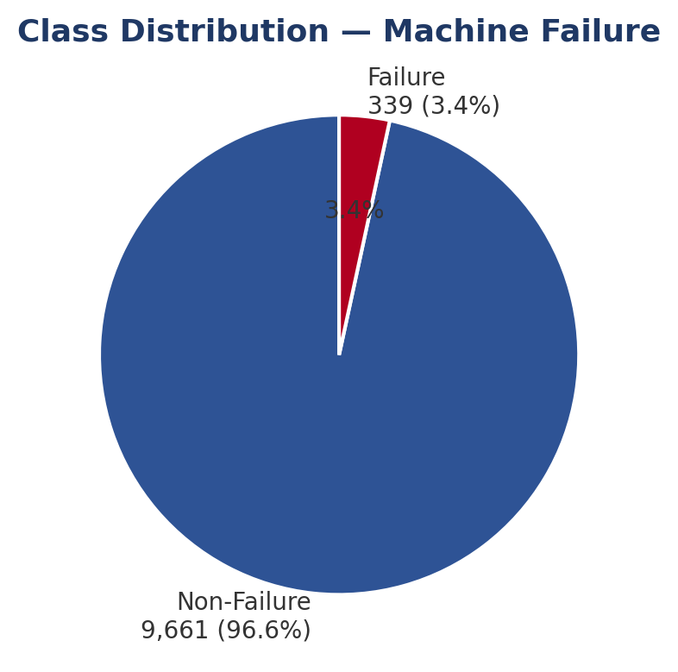
Figure 4.1 — Class distribution: Machine failure vs. non-failure.

4.2 Numerical Feature Distributions
Histograms of the five numeric features — air temperature, process temperature, rotational speed, torque, and tool wear — all look roughly symmetric and single-peaked, which is what you'd expect from a controlled industrial sensor setup. Boxplots show a few outliers in rotational speed and torque, mostly at the extreme ends — likely linked to Power Failure (PWF), which is specifically defined by unusually high or low power draw.

4.3 Correlation Analysis
A correlation heatmap across the numeric features and the failure target shows Torque and Tool Wear have the strongest link to failure, which makes sense since they directly define two of the five failure modes (OSF and TWF). Air temperature and process temperature turned out to be highly correlated with each other, which is why a Temperature Difference feature was engineered later (Section 6.3) to isolate the heat-dissipation signal more directly.
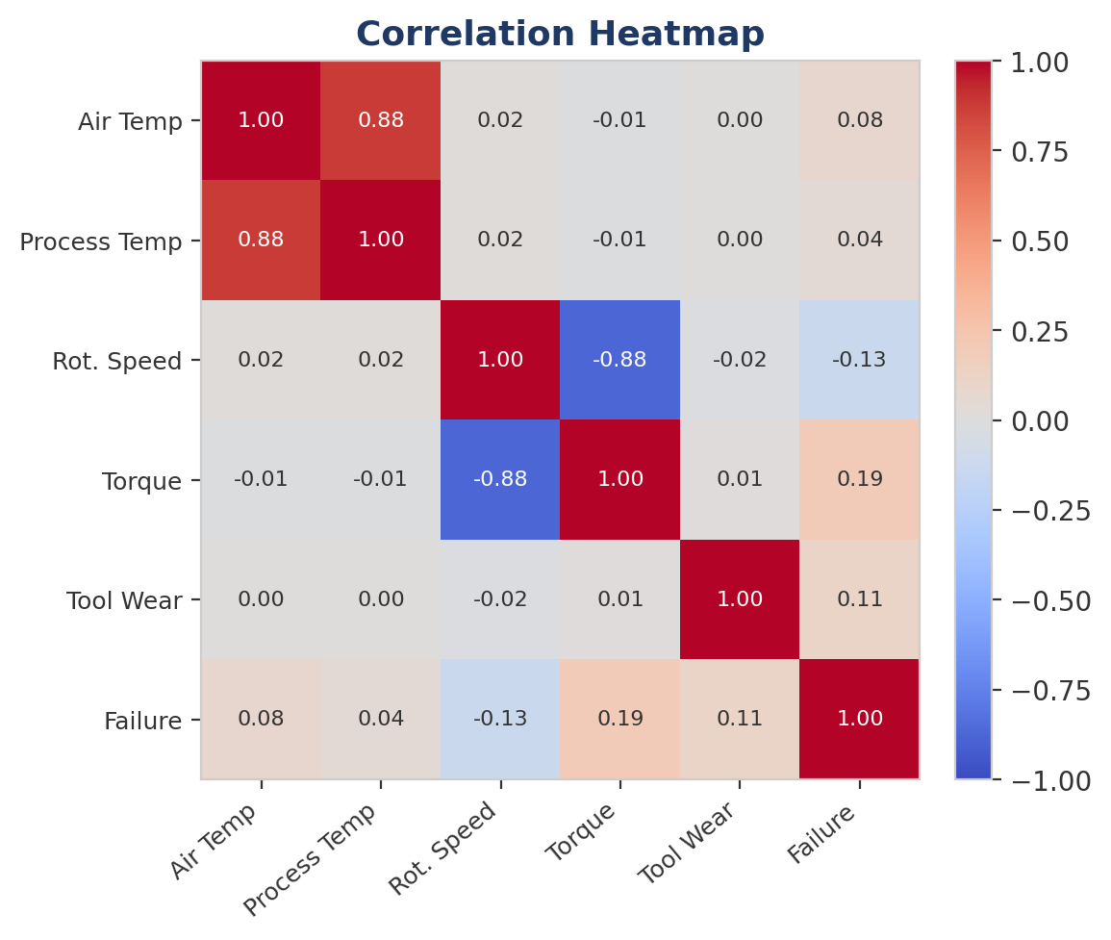
Figure 4.3 — Correlation heatmap of numerical features and the failure target.

4.4 Pairwise Relationships
Pairplots colored by failure status show that failures tend to cluster at the extreme values of Torque and Tool Wear rather than being spread randomly — another sign that these two features carry most of the useful signal for detecting failure.

4.5 Product Quality vs. Failure Rate
Grouping failure rate by product quality shows a mild pattern: Low-quality (L) parts fail a bit more often than Medium (M) or High (H) quality ones, which lines up with how the dataset was designed (lower-quality parts get a wider tool-wear failure window).
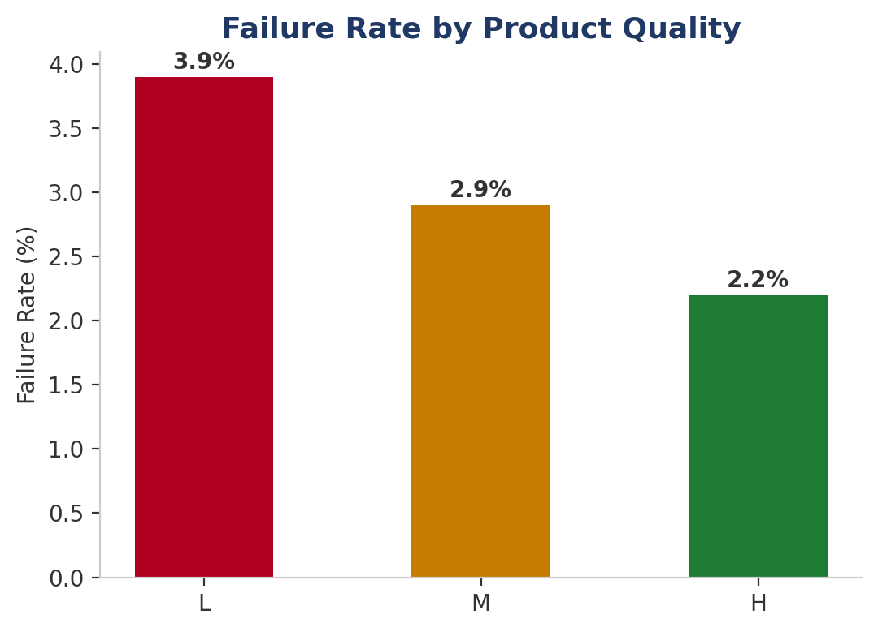
Figure 4.5 — Failure rate (%) by product quality variant.

4.6 Missing and Zero Values
There were no missing values anywhere (df.isnull().sum() came back all zeros). Some Tool Wear values are exactly zero, which just means a fresh or newly replaced tool — that's a valid reading, not a data problem, so those rows were kept as-is.

4.7 Stratified Feature Distributions
Kernel density plots split by failure status show Torque and Tool Wear having noticeably different shapes between failure and non-failure cases, while Air Temperature and Process Temperature overlap much more between the two groups — matching what the correlation analysis in Section 4.3 already suggested.

5. Failure Mode Analysis
The dataset defines five separate failure modes, each with its own physical trigger rule. The overall Machine failure flag is set to 1 if any one of these five conditions is met.
Mode | Full Name | Rule | Occurrences
TWF | Tool Wear Failure | Tool wear between 200–240 min | 120
HDF | Heat Dissipation Failure | Air–process temp diff < 8.6K and speed < 1,380 rpm | 115
PWF | Power Failure | Power < 3,500W or > 9,000W | 95
OSF | Overstrain Failure | Tool Wear × Torque exceeds threshold (L:11,000/M:12,000/H:13,000) | 98
RNF | Random Failure | 0.1% random chance, independent of sensors | 5
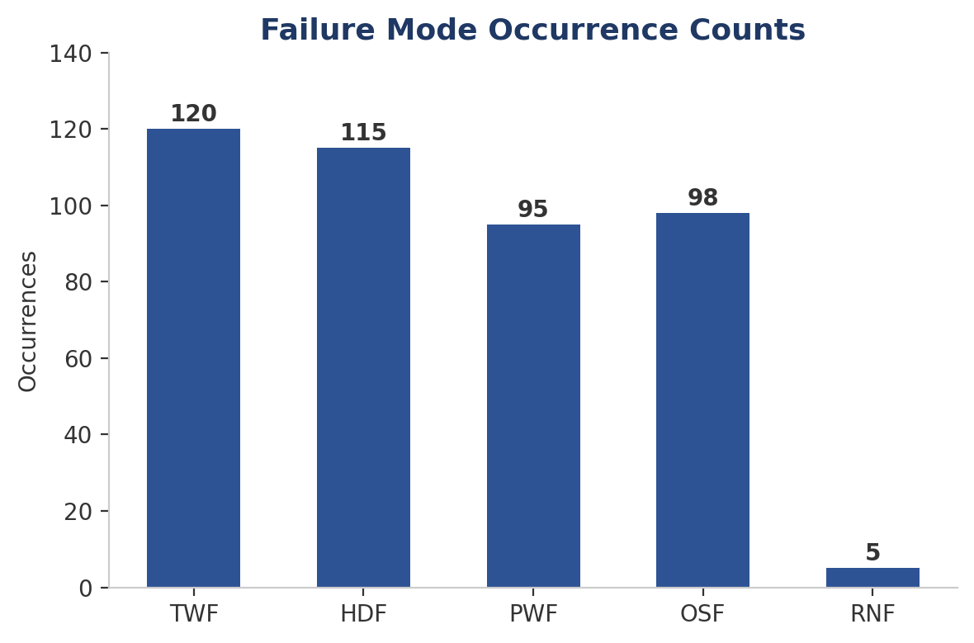
Figure 5.0 — Occurrence count for each of the five independent failure modes.

5.1 Most Frequent Failure Mode
Tool Wear Failure (TWF) shows up most often, with 120 occurrences, closely followed by Heat Dissipation Failure (HDF) at 115. Random Failure (RNF) is, by design, the rarest with only 5 cases.

5.2 Failure Mode Overlap
Because each mode has its own trigger condition, a single machine can technically hit more than one at the same time — for instance, high tool wear paired with high torque can satisfy both TWF and OSF at once. Looking at how many failure modes each record triggers confirms there's a small but real number of overlapping cases. This matters for the multi-class task in Section 11, since overlapping records need a rule for picking one label.

5.3 Summary
TWF was the most common of the five failure modes, with 120 occurrences overall. Several hundred machines experienced at least one failure, and a portion of those experienced more than one failure mode at once — especially when tool wear and torque were both high. That overlap is part of why this project treats failure mode classification carefully rather than just as a plain single-label binary problem.

6. Data Preprocessing & Feature Engineering

6.1 Data Cleaning
- Checked for duplicate rows with df.duplicated() and removed any that were found.
- Dropped the UID column since it's just an identifier with no predictive value, but kept Product ID in case it was useful for feature engineering.
- Confirmed there were zero missing values across every column using df.isnull().sum().

6.2 Categorical Encoding
The Type column (L, M, H for product quality) was label-encoded to integers (L→0, M→1, H→2) so it could be used in the models. One-hot encoding was considered too, but since the quality levels have a natural order (L < M < H), ordinal encoding made more sense.

6.3 Feature Engineering
Three new features were added to make the underlying physical failure conditions easier for the models to learn directly:
- Power [W] = Torque × Rotational Speed — mirrors the Power Failure (PWF) rule directly.
- Temperature Difference [K] = Process Temp − Air Temp — mirrors the Heat Dissipation Failure (HDF) rule directly.
- Wear × Torque = Tool Wear × Torque — mirrors the Overstrain Failure (OSF) rule directly.
Each of these matches exactly the quantity the dataset's own failure definitions are built on, so the models get a much clearer signal than the raw sensor values alone would give them.

6.4 Feature Scaling
Both StandardScaler and MinMaxScaler were tried on the numeric features. StandardScaler was kept for the main pipeline since it handles the mild outliers found in Section 4.2 better and suits the distance-based models (KNN, SVM) and the linear model (Logistic Regression) used later.

6.5 Train-Test Split
The data was split 75/25 into training and testing sets, using stratified splitting on the failure target so the 3.39% failure rate stayed consistent in both parts. That gave a training set of 7,246 non-failures and 254 failures, and a test set of 2,415 non-failures and 85 failures. The test set was never touched by resampling, feature selection, or tuning — it was kept purely for the final evaluation.

7. Handling Class Imbalance

7.1 Traditional Resampling Techniques
Seven resampling setups were tried on the training data (the test set was always left alone): the original imbalanced data, Random Oversampling, Random Undersampling, SMOTE, SMOTE-ENN, SMOTE-Tomek, ADASYN, and Borderline-SMOTE. A Logistic Regression model was trained on each version and tested on the same held-out set, so the comparison would be fair.
Technique | Precision | Recall | F1-Score | ROC-AUC
Original (Imbalanced) | 56.7% | 20.0% | 29.6% | 0.905
Random Oversampling | 16.6% | 82.4% | 27.6% | 0.922
Random Undersampling | 14.8% | 84.7% | 25.3% | 0.905
SMOTE | 18.0% | 82.4% | 29.6% | 0.922
SMOTE-ENN | 16.6% | 84.7% | 27.8% | 0.922
SMOTE-Tomek | 18.0% | 82.4% | 29.5% | 0.922
ADASYN | 15.3% | 88.2% | 26.1% | 0.922
Borderline-SMOTE | 19.9% | 81.2% | 32.0% | 0.905
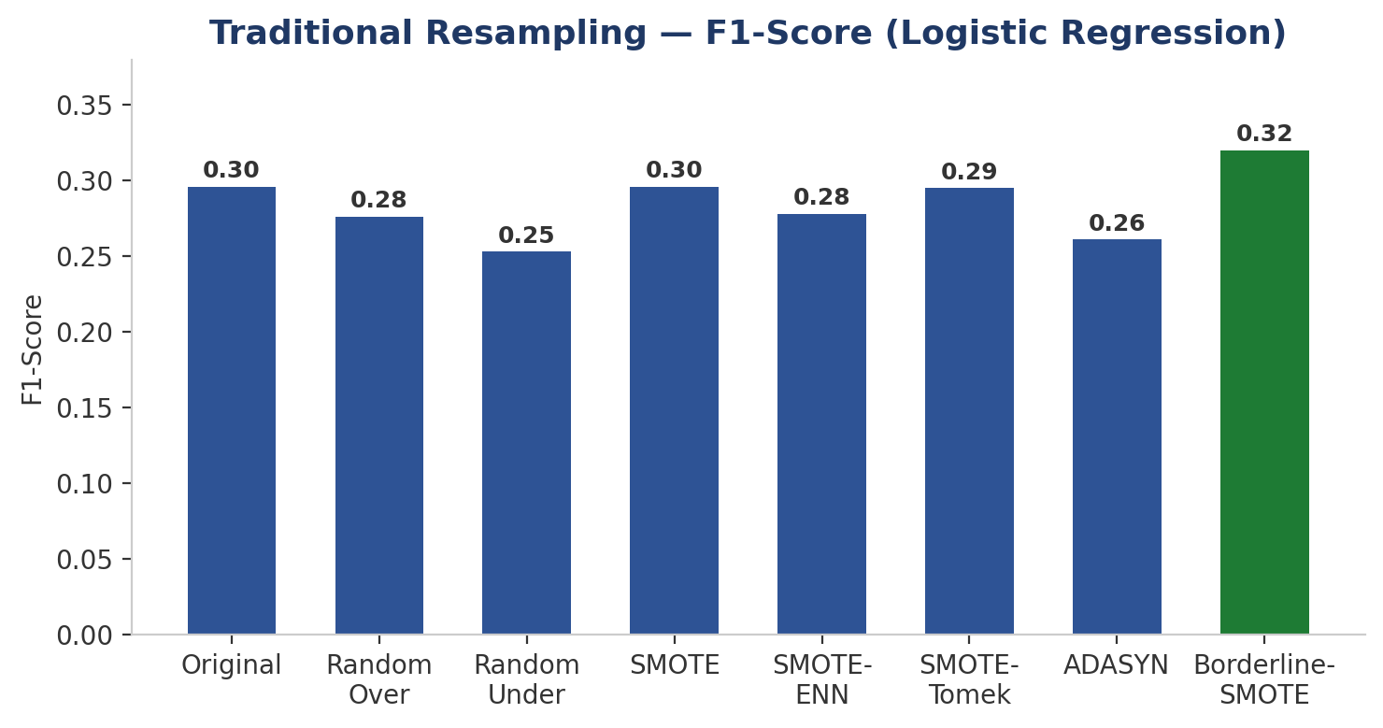
Figure 7.1 — F1-Score comparison across traditional resampling techniques (Logistic Regression).
Borderline-SMOTE gave the best F1-Score (0.320) of all the resampling methods tried, meaning it struck the best balance between Precision and Recall. The untouched imbalanced data had decent apparent accuracy but very poor Recall (20.0%) — the model was basically just guessing "no failure" most of the time. SMOTE and its variants improved Recall a lot by generating synthetic minority samples, usually at some cost to Precision, while Random Undersampling shrank the training set drastically (down to just 508 records), risking a loss of useful information.

7.2 Generative AI / Synthetic Data Generation
Beyond SMOTE-family methods, generative-AI models were also tried, generating new synthetic failure samples straight from the 254 real failure records in the training set:
- SMOTE-NC was used to correctly handle the mix of categorical and continuous features without needing full one-hot expansion.
- CTGAN (Conditional Tabular GAN) was trained on the 254 real failure samples and used to generate 6,992 synthetic ones to balance the training set.
- TVAE (Tabular Variational Autoencoder) was trained the same way, also generating 6,992 synthetic failure records.
- CopulaGAN was set up as part of checking the distribution structure.
t-SNE and UMAP were used to visually compare the real and CTGAN-generated failure samples, as a rough check of whether the generator was producing realistic data or something closer to noise.

7.3 SMOTE vs. Generative AI — Direct Comparison
Technique | Precision | Recall | F1-Score | ROC-AUC | PR-AUC
Logistic Regression — SMOTE | 18.0% | 82.4% | 29.6% | 0.922 | 0.375
Logistic Regression — CTGAN | 10.7% | 36.5% | 16.5% | 0.615 | 0.115
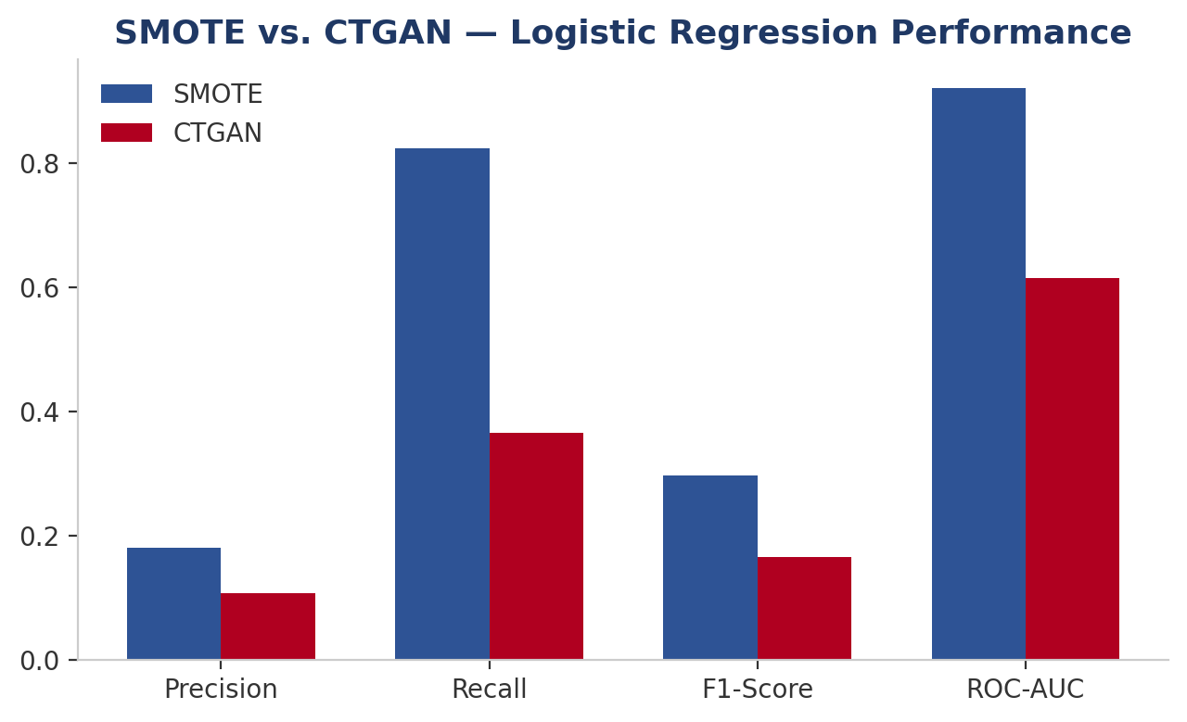
Figure 7.3 — SMOTE vs. CTGAN performance comparison (Logistic Regression).
On this dataset, SMOTE clearly beat CTGAN across every metric, including a much higher ROC-AUC (0.922 vs. 0.615). The most likely reason is simply that there weren't enough real failure examples (only 254) for a deep generative model like CTGAN to learn a reliable picture of the true failure distribution. SMOTE's simpler nearest-neighbor approach doesn't need nearly as much data and turned out to be much better suited here. This result directly shaped the final recommendation in Section 12.

8. Machine Learning Models
Seven binary classification setups were trained and tested on the held-out set:
# | Model | Training Data | Key Configuration
1 | Logistic Regression | Original (imbalanced) | max_iter=1000 — baseline
2 | Logistic Regression | SMOTE-balanced | max_iter=1000
3 | Logistic Regression | CTGAN-generated | max_iter=1000 — generative AI comparison
4 | K-Nearest Neighbors | SMOTE-balanced | k = 5
5 | Support Vector Machine | SMOTE-balanced | RBF kernel, probability=True
6 | Decision Tree | Original + class weights | class_weight='balanced', max_depth=6
7 | Random Forest | Original + class weights | 100 estimators, class_weight='balanced_subsample'

8.1 Modeling Rationale
- Logistic Regression is easy to interpret and was run three ways (imbalanced, SMOTE, CTGAN) to compare imbalance-handling strategies while keeping the model itself fixed.
- KNN and SVM were trained on SMOTE-balanced data since distance- and margin-based algorithms tend to be quite sensitive to class imbalance.
- Decision Tree and Random Forest instead used class_weight='balanced' (or 'balanced_subsample') on the original data, letting the splitting rule itself account for the imbalance instead of altering the data.

8.2 Algorithm Descriptions

8.2.1 Logistic Regression
Logistic Regression models the log-odds of a failure as a linear combination of the inputs, passed through a sigmoid to get a probability. It trains fast, is easy to interpret (each coefficient shows a feature's direction and rough strength of influence), and works as a solid baseline for comparing against more complex models. Its main weakness here is the linear decision boundary — it can't capture the kind of feature interactions (like Tool Wear with Torque) that several failure modes are actually built on.

8.2.2 K-Nearest Neighbors (KNN)
KNN classifies a new record by majority vote among its 5 closest training records, measured with Euclidean distance in the scaled feature space. It doesn't assume anything about the data's shape and can pick up non-linear patterns, but it's sensitive to feature scaling (handled via StandardScaler, Section 6.4) and to imbalance (handled by training on SMOTE-balanced data).

8.2.3 Support Vector Machine (SVM)
SVM finds the hyperplane that best separates the two classes with the widest margin. An RBF kernel was used to let it capture non-linear boundaries, and probability estimates were turned on to support ROC and Precision-Recall curves later. Like KNN, it was trained on SMOTE-balanced data because of its sensitivity to imbalance.

8.2.4 Decision Tree
A Decision Tree splits the data step by step based on feature thresholds, which fits naturally with how the dataset's own failure rules are defined (e.g., tool wear between 200 and 240 minutes). class_weight='balanced' was used so the tree pays proportionally more attention to the rare failure class instead of ignoring it, and max_depth was capped at 6 to avoid overfitting.

8.2.5 Random Forest
Random Forest builds many decision trees on random subsets of data and features, then combines their votes. This reduces the overfitting risk a single tree has while keeping the same ability to model threshold-based rules. class_weight='balanced_subsample' handled the imbalance directly, without needing any synthetic data at all.

9. Model Evaluation
Model | Accuracy | Precision | Recall | F1-Score | ROC-AUC | PR-AUC
LR (Imbalanced) | 96.76% | 56.67% | 20.00% | 29.57% | 0.905 | 0.442
LR (SMOTE) | 86.68% | 18.04% | 82.35% | 29.60% | 0.922 | 0.375
LR (CTGAN) | 87.44% | 10.65% | 36.47% | 16.49% | 0.615 | 0.115
KNN (SMOTE) | 93.52% | 32.26% | 82.35% | 46.36% | 0.914 | 0.550
SVM (SMOTE) | 92.80% | 30.92% | 90.59% | 46.11% | 0.975 | 0.660
Decision Tree | 94.92% | 38.71% | 84.71% | 53.14% | 0.874 | 0.802
Random Forest | 99.12% | 95.65% | 77.65% | 85.71% | 0.978 | 0.863

9.1 Confusion Matrices
Confusion matrices were plotted for all seven models. Logistic Regression on the imbalanced data shows the classic problem: very few false positives, but a lot of false negatives — real failures that got missed, which is the worst kind of error for a maintenance system to make. Random Forest looks very different: both false positives and false negatives are low, correctly catching 66 of the 85 true failures while barely raising any false alarms.
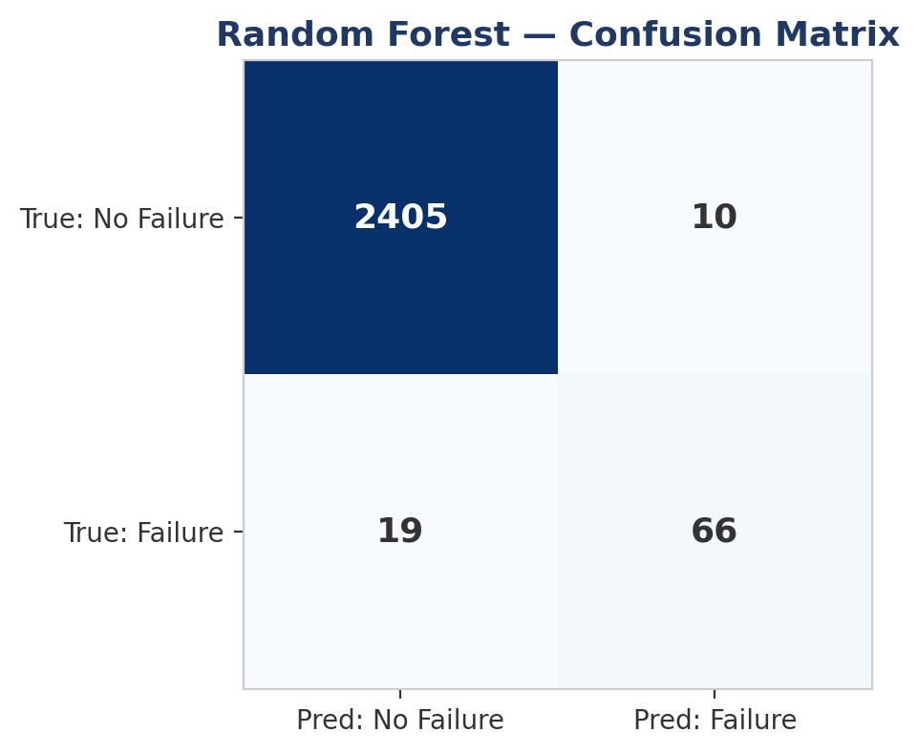
Figure 9.1 — Confusion matrix for the recommended Random Forest model on the held-out test set.

9.2 ROC and Precision-Recall Curves
ROC curves for all seven models were plotted together. Random Forest (0.978) and SVM (0.975) score highest, with Random Forest keeping the best trade-off across almost the entire curve. Since ROC-AUC can look overly optimistic under heavy imbalance (it's boosted by the large number of easy true negatives), the Precision-Recall curves tell a more honest story — and there, Random Forest's PR-AUC of 0.863 stands well clear of the next-best model, Decision Tree at 0.802.
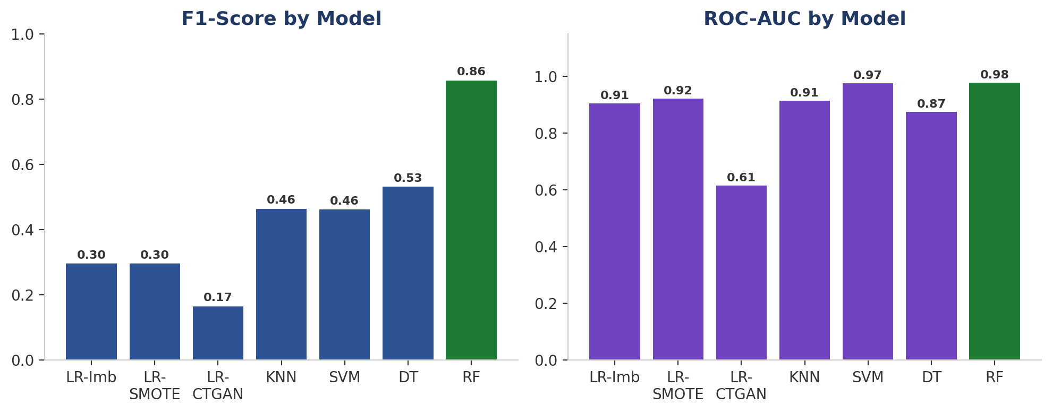
Figure 9.2 — F1-Score and ROC-AUC across all seven model configurations.

9.3 Per-Model Discussion

9.3.1 Logistic Regression (Imbalanced)
Trained directly on the raw imbalanced data, this model has the highest accuracy of the three Logistic Regression versions (96.76%) and a decent Precision (56.67%), but its Recall is only 20.00% — meaning it misses 4 out of every 5 real failures. That's a bad outcome for a maintenance system, and it's a good example of why accuracy alone can be misleading under heavy imbalance.

9.3.2 Logistic Regression (SMOTE)
Balancing the data with SMOTE pushes Recall up sharply to 82.35%, but Precision drops to 18.04% (lots of false alarms) and accuracy falls to 86.68%. The F1-Score (29.60%) ends up almost identical to the imbalanced version — SMOTE mostly just shifts where the model sits on the Precision/Recall trade-off rather than making it fundamentally better at telling the classes apart.

9.3.3 Logistic Regression (CTGAN)
This is the weakest model in the whole study (F1 = 16.49%, ROC-AUC = 0.615). Its Recall (36.47%) is far below the SMOTE version's, suggesting the CTGAN-generated failure examples didn't capture the real decision boundary well — likely because the generator only had 254 real examples to learn from, as discussed in Section 7.3.

9.3.4 K-Nearest Neighbors
KNN on SMOTE-balanced data reaches a strong Recall (82.35%), matching Logistic Regression-SMOTE, but with noticeably better Precision (32.26% vs. 18.04%), giving it a clearly higher F1-Score (46.36%). Its non-linear decision boundary seems to suit this data better than a straight linear model, though it's still well behind the tree-based methods.

9.3.5 Support Vector Machine
SVM has the highest Recall of any model tested (90.59%), catching almost every true failure, and the second-highest ROC-AUC (0.975) after Random Forest. Precision (30.92%) is similar to KNN's, giving an F1-Score of 46.11%. Its PR-AUC (0.660) — second-best overall — suggests SVM could probably do even better with a different probability threshold if Recall really matters most.

9.3.6 Decision Tree
The class-weighted Decision Tree is the strongest non-ensemble model, with an F1-Score of 53.14% and a PR-AUC of 0.802, second only to Random Forest. Its threshold-based splits line up naturally with the dataset's own rule-based failure definitions, letting it carve out decision regions closer to the true underlying physics than the smoother boundaries of Logistic Regression, KNN, or SVM.

9.3.7 Random Forest
Random Forest is clearly the best model in this study, leading on every metric: 99.12% accuracy, 95.65% Precision, 77.65% Recall, 85.71% F1-Score, 0.978 ROC-AUC, 0.863 PR-AUC. Unlike the other models, it doesn't have to trade off Precision against Recall — it does well on both at once, which points to a genuinely well-separated decision boundary rather than just a lucky threshold. Combining many trees with balanced-subsample class weighting lets it capture the rule-like structure of the data while handling the imbalance directly, with no synthetic data needed.

9.4 Interpretation Summary
- Logistic Regression on the raw data has the best Precision among the linear models (56.7%) but unacceptably low Recall (20.0%) — it misses 4 out of 5 real failures.
- SMOTE-balanced models (LR, KNN, SVM) trade Precision for much higher Recall (82–91%), which could make sense if missing a failure is far costlier than a false alarm.
- CTGAN-balanced Logistic Regression trails SMOTE on every single metric, backing up the Section 7.3 finding that CTGAN wasn't effective at this small a sample size.
- Random Forest with class weights beats everything on every metric at once — it simply doesn't face the same trade-off the other models do.

10. Model Comparison

10.1 Consolidated Comparison
Putting together the results from Sections 7 and 9, ranking by F1-Score (the balanced measure of Precision and Recall) gives:
Rank | Model | F1-Score | PR-AUC
1 | Random Forest (Weighted) | 85.71% | 0.863
2 | Decision Tree (Weighted) | 53.14% | 0.802
3 | KNN (SMOTE) | 46.36% | 0.550
4 | SVM (SMOTE) | 46.11% | 0.660
5 | LR (SMOTE) | 29.60% | 0.375
6 | LR (Imbalanced) | 29.57% | 0.442
7 | LR (CTGAN) | 16.49% | 0.115
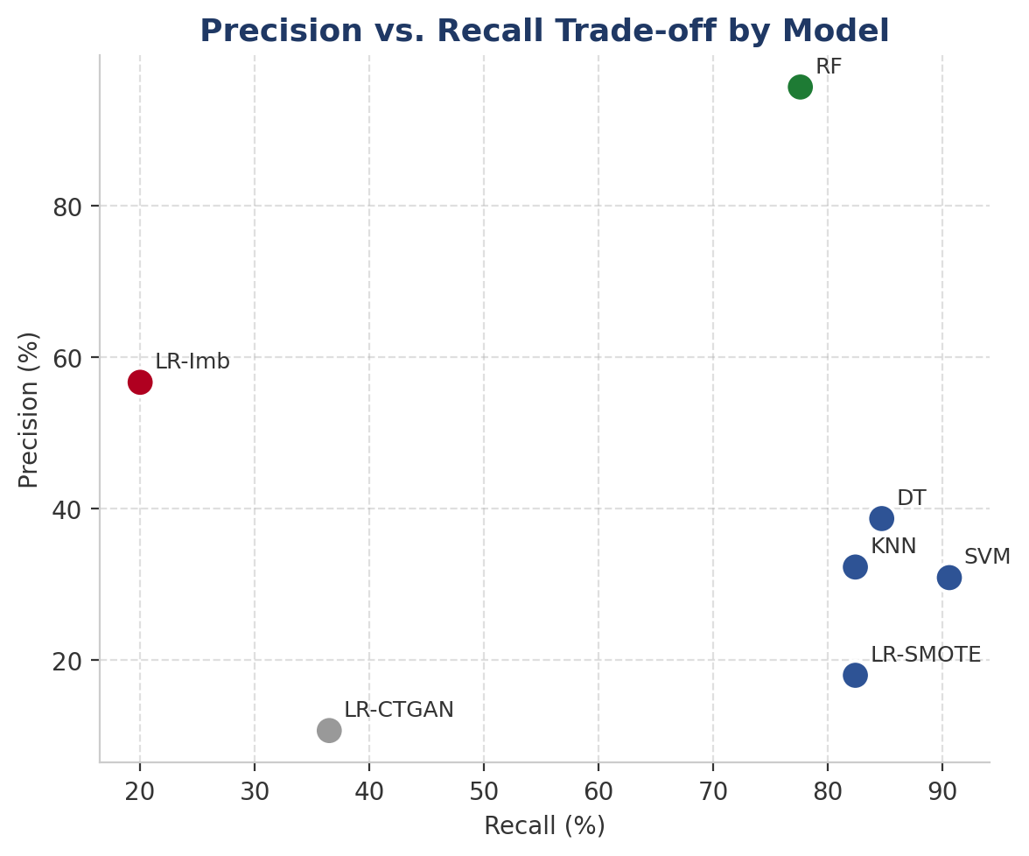
Figure 10.1 — Precision vs. Recall trade-off across all seven models.

10.2 Comparison Across Data Strategies
Holding the model fixed (Logistic Regression) and only changing the imbalance strategy shows the effect of the data approach in isolation: the raw imbalanced data gives high Precision/low Recall, SMOTE flips that to low Precision/high Recall with about the same F1-Score, and CTGAN underperforms both. This suggests the choice of classifier (tree-based ensembles vs. linear/instance-based methods) matters a lot more here than the resampling technique — the jump from Logistic Regression to Random Forest (F1: 29.6% → 85.7%) dwarfs anything achievable just by switching resampling methods.

10.3 Recommended Model
Random Forest with balanced class weights, trained directly on the original data, is the model recommended for deployment. It leads on every metric tracked in this study, doesn't need any synthetic data generation step (which simplifies the production pipeline), and its ensemble structure adds some natural robustness against the outliers noted in Section 4.2.

11. Failure Mode Classification — Multi-Class Task
Knowing that a failure will happen isn't the whole story — a really useful system should also say which failure mode is behind it, so the right maintenance action can be taken. That's the motivation for extending the binary classifier into a six-class task.

11.1 Multi-Class Target Construction
A single Failure_Class column was built from the five binary failure indicators: 0 = No Failure, 1 = TWF, 2 = HDF, 3 = PWF, 4 = OSF, 5 = RNF. Where a record matched more than one condition (as discussed in Section 5.2), the modes were applied in a fixed priority order — TWF → HDF → PWF → OSF → RNF — so every record ended up with exactly one label.

11.2 Class Distribution and Balancing
Class | Label | Count (Before SMOTE) | Count (After SMOTE)
0 | No Failure | 7,722 | 7,722
1 | TWF | 34 | 7,722
2 | HDF | 85 | 7,722
3 | PWF | 66 | 7,722
4 | OSF | 78 | 7,722
5 | RNF | 15 | 7,722
The imbalance here is even worse than in the binary case — the rarest class (RNF, 15 records) is over 500 times smaller than the majority class. SMOTE was used to bring all six classes up to 7,722 records each before training.

11.3 Multi-Class Model and Results
A Random Forest with 100 estimators was trained on the SMOTE-balanced multi-class data and tested on a held-out set of 2,000 records.
Class | Precision | Recall |  | F1-Score | Support
No Failure (0) | 1.00 | 1.00 |  | 1.00 | 1,930
TWF (1) | 0.80 | 1.00 |  | 0.89 | 8
HDF (2) | 1.00 | 1.00 |  | 1.00 | 21
PWF (3) | 1.00 | 1.00 |  | 1.00 | 17
OSF (4) | 1.00 | 0.95 |  | 0.97 | 20
RNF (5) | 1.00 | 0.75 |  | 0.86 | 4
Overall Metric |  |  | Score
Macro F1-Score |  |  | 95.34%
Weighted F1-Score |  |  | 99.90%
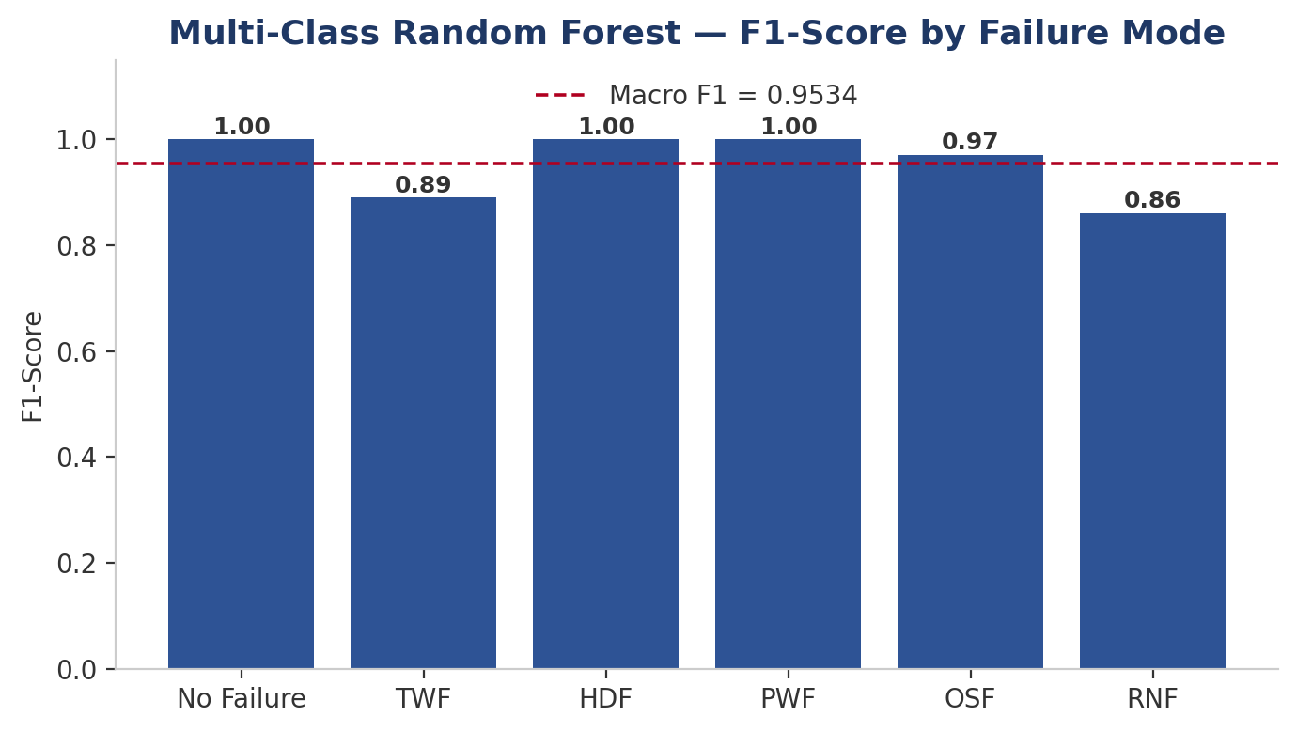
Figure 11.3 — Per-class F1-Score for the multi-class Random Forest failure-mode classifier.

11.4 Interpretation
The Macro F1-Score of 95.34% (which treats every class equally, however rare) shows that even the rarest classes — TWF and RNF, with just 8 and 4 test examples — get classified well once the imbalance is properly corrected with SMOTE. The Weighted F1-Score of 99.90% just reflects that the huge majority class (No Failure) is classified almost perfectly. The confusion matrix shows the few errors that do happen are mostly between RNF and No Failure — which makes sense, since RNF is defined by pure chance rather than any sensor pattern, making it the hardest class to actually learn.

12. Conclusion & Recommendations

12.1 Key Findings
- Random Forest with balanced class weights is the best binary failure detector overall — F1 = 85.7%, Precision = 95.7%, Recall = 77.6%, ROC-AUC = 0.978, PR-AUC = 0.863 — beating every other model and imbalance strategy tested.
- Classic SMOTE-family resampling beat the CTGAN generative approach on this dataset; Borderline-SMOTE gave the best F1-Score (0.320) among resamplers, while CTGAN-balanced Logistic Regression was the weakest model overall — likely because there were only 254 real minority-class examples to train the generator on.
- Feature engineering that mirrors the dataset's own failure definitions (Power, Temperature Difference, Wear × Torque) gave the models a much more direct signal than the raw sensor readings.
- Multi-class failure-mode classification reached 95.3% Macro-F1 and 99.9% Weighted-F1, showing the five failure mechanisms are highly distinguishable once class imbalance is corrected.
- Torque and Tool Wear were consistently the two most useful raw features across both the binary and multi-class tasks, which fits with their direct role in the OSF and TWF definitions.

12.2 Recommendations
- Deploy the class-weighted Random Forest as the main production failure detector — it needs no synthetic data step, which keeps the pipeline simpler, and it delivers the best results of anything tested.
- Prioritize Recall and PR-AUC over raw accuracy in any future model iteration, since accuracy is misleading given the 96.6% majority-class baseline.
- If resampling is still preferred (e.g., for a simpler linear model), use Borderline-SMOTE rather than CTGAN or other deep generative methods, given the small minority-class sample size here; save generative AI for problems with much larger minority-class pools.
- Extend the deployed system to the multi-class output from Section 11 so maintenance teams get a specific diagnosis (TWF, HDF, PWF, OSF, or RNF) instead of a plain binary alert.
- Keep monitoring Torque, Tool Wear, and the engineered Temperature Difference feature closely in production, since they were consistently the strongest predictors throughout.
- Treat any RNF-labeled prediction with some caution in production, since RNF is defined purely by chance — no sensor-based model can really be expected to predict a failure mode that's independent of sensor readings by design.

12.3 Limitations
- The dataset is synthetic; checking these findings against real-world sensor data from a similar industrial process would build more confidence before deployment.
- The generative-AI comparison (CTGAN, TVAE) was limited by the small number of real failure examples; repeating it on a larger real-world dataset might change the conclusions about how competitive generative methods really are against SMOTE.
- Hyperparameter tuning (grid search or Bayesian search) wasn't done exhaustively for Random Forest; more tuning could likely squeeze out further gains.

Appendix A: Detailed Classification Reports
Full per-class precision/recall/F1 reports for each of the seven binary models, generated with scikit-learn's classification_report, are reproduced below for reference.

A.1 Logistic Regression (Imbalanced Data)
Class | Precision | Recall | F1-Score | Support
0 | 0.97 | 0.99 | 0.98 | 2415
1 | 0.57 | 0.20 | 0.30 | 85
accuracy |  |  | 0.97 | 2500
macro avg | 0.77 | 0.60 | 0.64 | 2500
weighted avg | 0.96 | 0.97 | 0.96 | 2500

A.2 Logistic Regression (SMOTE-Balanced Data)
Class | Precision | Recall | F1-Score | Support
0 | 0.99 | 0.87 | 0.93 | 2415
1 | 0.18 | 0.82 | 0.30 | 85
accuracy |  |  | 0.87 | 2500
macro avg | 0.59 | 0.85 | 0.61 | 2500
weighted avg | 0.97 | 0.87 | 0.91 | 2500

A.3 Logistic Regression (CTGAN-Generated Data)
Class | Precision | Recall | F1-Score | Support
0 | 0.98 | 0.89 | 0.93 | 2415
1 | 0.11 | 0.36 | 0.16 | 85
accuracy |  |  | 0.87 | 2500
macro avg | 0.54 | 0.63 | 0.55 | 2500
weighted avg | 0.95 | 0.87 | 0.91 | 2500

A.4 K-Nearest Neighbors (SMOTE-Balanced Data)
Class | Precision | Recall | F1-Score | Support
0 | 0.99 | 0.94 | 0.97 | 2415
1 | 0.32 | 0.82 | 0.46 | 85
accuracy |  |  | 0.94 | 2500
macro avg | 0.66 | 0.88 | 0.71 | 2500
weighted avg | 0.97 | 0.94 | 0.95 | 2500

A.5 Support Vector Machine (SMOTE-Balanced Data)
Class | Precision | Recall | F1-Score | Support
0 | 1.00 | 0.93 | 0.96 | 2415
1 | 0.31 | 0.91 | 0.46 | 85
accuracy |  |  | 0.93 | 2500
macro avg | 0.65 | 0.92 | 0.71 | 2500
weighted avg | 0.97 | 0.93 | 0.94 | 2500

A.6 Decision Tree (Class-Weighted)
Class | Precision | Recall | F1-Score | Support
0 | 0.99 | 0.95 | 0.97 | 2415
1 | 0.39 | 0.85 | 0.53 | 85
accuracy |  |  | 0.95 | 2500
macro avg | 0.69 | 0.90 | 0.75 | 2500
weighted avg | 0.97 | 0.95 | 0.96 | 2500

A.7 Random Forest (Class-Weighted) — Recommended Model
Class | Precision | Recall | F1-Score | Support
0 | 0.99 | 1.00 | 1.00 | 2415
1 | 0.96 | 0.78 | 0.86 | 85
accuracy |  |  | 0.99 | 2500
macro avg | 0.97 | 0.89 | 0.93 | 2500
weighted avg | 0.99 | 0.99 | 0.99 | 2500

A.8 Multi-Class Random Forest (SMOTE-Balanced, 6 Classes)
Class | Precision | Recall | F1-Score | Support
No Failure (0) | 1.00 | 1.00 | 1.00 | 1930
TWF (1) | 0.80 | 1.00 | 0.89 | 8
HDF (2) | 1.00 | 1.00 | 1.00 | 21
PWF (3) | 1.00 | 1.00 | 1.00 | 17
OSF (4) | 1.00 | 0.95 | 0.97 | 20
RNF (5) | 1.00 | 0.75 | 0.86 | 4
accuracy |  |  | 1.00 | 2000
macro avg | 0.97 | 0.95 | 0.95 | 2000
weighted avg | 1.00 | 1.00 | 1.00 | 2000

Appendix B: Glossary of Metrics and Terms
Term | Definition
Accuracy | Share of all predictions that are correct. Can be misleading under class imbalance.
Precision | Of everything predicted as a failure, the share that was actually a failure.
Recall (Sensitivity) | Of all actual failures, the share correctly caught. Critical here since missing a failure is usually far worse than a false alarm.
F1-Score | The harmonic mean of Precision and Recall — a single balanced number, especially useful when the two need to be weighed against each other.
ROC-AUC | Area under the ROC curve; measures overall ranking quality across thresholds.
PR-AUC | Area under the Precision-Recall curve; more informative than ROC-AUC under heavy imbalance since it isn't inflated by a large true-negative pool.
Macro F1-Score | F1-Score averaged equally across all classes, regardless of size — sensitive to how well rare classes are handled.
Weighted F1-Score | F1-Score averaged across classes weighted by class size — dominated by the majority class.
SMOTE | Synthetic Minority Oversampling Technique — creates synthetic minority samples by interpolating between real samples and their nearest neighbors.
CTGAN | Conditional Tabular GAN — a deep generative model for creating realistic tabular data, including mixed categorical/continuous columns.
TVAE | Tabular Variational Autoencoder — a deep generative model that learns a latent representation of tabular data and samples new records from it.
Class Imbalance | When one class (here, non-failure) vastly outnumbers another (failure), which can bias naive classifiers toward always predicting the majority class.

Appendix C: Reproducibility & Environment
These details are included so the results in this report can be reproduced from the accompanying Jupyter Notebook.

C.1 Random Seeds
All random operations — train-test splitting, resampling (Random Oversampling, Random Undersampling, SMOTE and its variants), and model initialization (Decision Tree, Random Forest) — used a fixed random_state = 42, so the results here can be exactly reproduced from the notebook.

C.2 Package Versions
The pipeline relies on pandas, NumPy, matplotlib, seaborn, scikit-learn, imbalanced-learn (imblearn), sdv (CTGAN/TVAE/CopulaGAN), scikit-learn's TSNE implementation, and umap-learn. Exact versions are pinned in the notebook's environment; using significantly newer or older major versions of scikit-learn or imbalanced-learn could produce small numerical differences from the figures reported here.

C.3 Data Split Summary
Split | Non-Failure | Failure | Total
Training (75%) | 7,246 | 254 | 7,500
Testing (25%) | 2,415 | 85 | 2,500
Total | 9,661 | 339 | 10,000

C.4 File Deliverables
- Jupyter Notebook (.ipynb) — complete code, markdown explanations, and outputs for all ten project stages.
- This report (.docx) — methodology, results, and recommendations.
- PowerPoint presentation (.pptx) — condensed visual summary for stakeholder review.
- Trained model artifacts, where applicable, for the recommended Random Forest classifier.

Appendix D: Descriptive Statistics
Summary statistics (df.describe()) for the five core numerical features, computed on the full 10,000-record dataset before any scaling or splitting.
Statistic | Air Temp [K] | Process Temp [K] | Rot. Speed [rpm] | Torque [Nm] | Tool Wear [min]
Mean | 300.00 | 310.01 | 1538.78 | 39.99 | 107.95
Std Dev | 2.00 | 1.48 | 179.28 | 9.97 | 63.65
Min | 295.30 | 305.70 | 1168 | 3.80 | 0
25% | 298.30 | 308.80 | 1423 | 33.20 | 53
50% (Median) | 300.10 | 310.10 | 1503 | 40.10 | 108
75% | 301.50 | 311.10 | 1612 | 46.80 | 162
Max | 304.50 | 313.80 | 2886 | 76.60 | 253
These numbers confirm the numerical features stay within well-controlled, physically reasonable ranges typical of a milling-machine sensor setup, with nothing extreme enough to need correction. That's part of why no extra outlier removal was applied beyond what StandardScaler already handles through normalization.

